Lab - Configure a Wireless Network

# Introduction

In this lab, you will configure basic settings on a wireless router and connect a PC to router wirelessly.

# Recommended Equipment

* A Windows computer with wired and wireless network cards installed
* Wireless router
* Ethernet patch cable

**Note**: All wireless settings in this lab are for a 2.4 GHz wireless connection. Follow the same steps for setting up a 5 GHz wireless connection or when setting up both 2.4 GHz and 5 GHz connections.

# Instructions

## Log into the Wireless Router

### Connect the computer to the router.

* + - 1. Ask the instructor for the following information that is used during the lab.

**Router Address Information:**

IP address:

Type your answers here.

Subnet mask:

Type your answers here.

Router name:

Type your answers here.

**DHCP Server Setting Information:**

Start IP address:

Type your answers here.

Maximum number of users:

Type your answers here.

**Default Router Access:**

Router Username / Password:

Type your answers here.

**Assigned SSID:**

Your Assigned SSID:

Type your answers here.

**Note**: Only use configurations assigned by the instructor.

* + - 1. Plug in the power for the wireless router. Boot the computer and log in as an administrator.
      2. Connect the computer to one of the **Ethernet** ports on the wireless router with an Ethernet patch cable.

**Note**: If this is the first time connecting to the lab router, follow these instructions to set a network location. This will be explained later in the course.

* + - 1. If prompted by the **Set Network Location** window, select **Public network**. Click **Close** to accept the network location Public.
      2. Open a command prompt and type **ipconfig** to determine the IP address of the default gateway, which should be the IP address of your wireless router. If it is necessary to renew the IP address, enter **ipconfig /all** at the prompt.

#### Question:

What is the default gateway for the computer?

Type your answers here.

### Log in to the router.

* + - 1. Open **Microsoft Edge** or other web browsers. Enter the IP address of your default gateway in the **Address** field, and then press **Enter**.
      2. In the **Windows Security** window, enter administrative user credentials provided by your instructor.

## Configure Basic Wireless Settings

In this lab, you will not be configuring the wireless router to the internet. You will configure the SSID or network name and security in the wireless settings, configure DHCP settings, and set a new administrative password.

### Configure SSID.

* + - 1. Locate the wireless settings. In the SSID or network name field, enter your assigned SSID.
      2. Save the settings.

### Configure wireless security.

* + - 1. Locate the wireless security settings.
      2. Select WPA2 security option. Select AES cipher and personal if available.
      3. Enter a passphrase or password as assigned by your instructor or use **Cisco456!** as an example.
      4. Save the settings.

### Configure DHCP settings.

* + - 1. Locate the LAN settings.
      2. Configure router device name if available.
      3. Configure the router's IP address and subnet mask as assigned by your instructor.
      4. Verify that the wireless router is used as the DHCP server.
      5. Configure the LAN information for your assigned subnet. If possible, you may be providing the starting and end IP addresses or the maximum number of IP addresses available for connecting hosts wirelessly.
      6. Save the settings.
      7. The router may need to reboot at this time. If necessary, reboot the router.

### Change the default administrative password.

* + - 1. Locate the password settings for the administrative account.
      2. Provide the current password and the new password as assigned by your instructor or C**isco123!**.
      3. Save the settings.
      4. Log into the wireless using the new credentials: **admin** / **Cisco123!** or the credentials that were assigned to you.
      5. At this time, you can disconnect the Ethernet cable if desired.

## Connect a Wireless Client

* + - 1. Click **Start**, enter **wireless**. Select **Change Wi-Fi Settings**.
      2. In Wi-Fi settings window, select **Show available networks**.
      3. Select the configured SSID that you configured in a previous step.
      4. Enter the password or passphrase configured in a previous step.
      5. Open a command prompt. Type **ipconfig** and record the following information.

**Computer IP information**:

IP address:

Type your answers here.

Subnet mask:

Type your answers here.

Default Gateway:

Type your answers here.

## Connect an Access Point (Optional)

In this part, you will add a wireless access point (AP) to the network. An AP is connected directly to a wireless router using an Ethernet cable. The purpose of an AP is to extend the wireless LAN where the wireless users cannot reach the wireless router otherwise.

In this part, you may need to partner with another group with a wireless router that can be converted to an access point. Or your instructor may also provide an access point. Unless instructed to connect the wireless router the internet, you do not need to connect the Internet port of the wireless router to a cable or DSL connection.

**Note**: If you are converting a wireless router to an AP, please follow the instructions provided by your instructor or manufacturer's documentations.

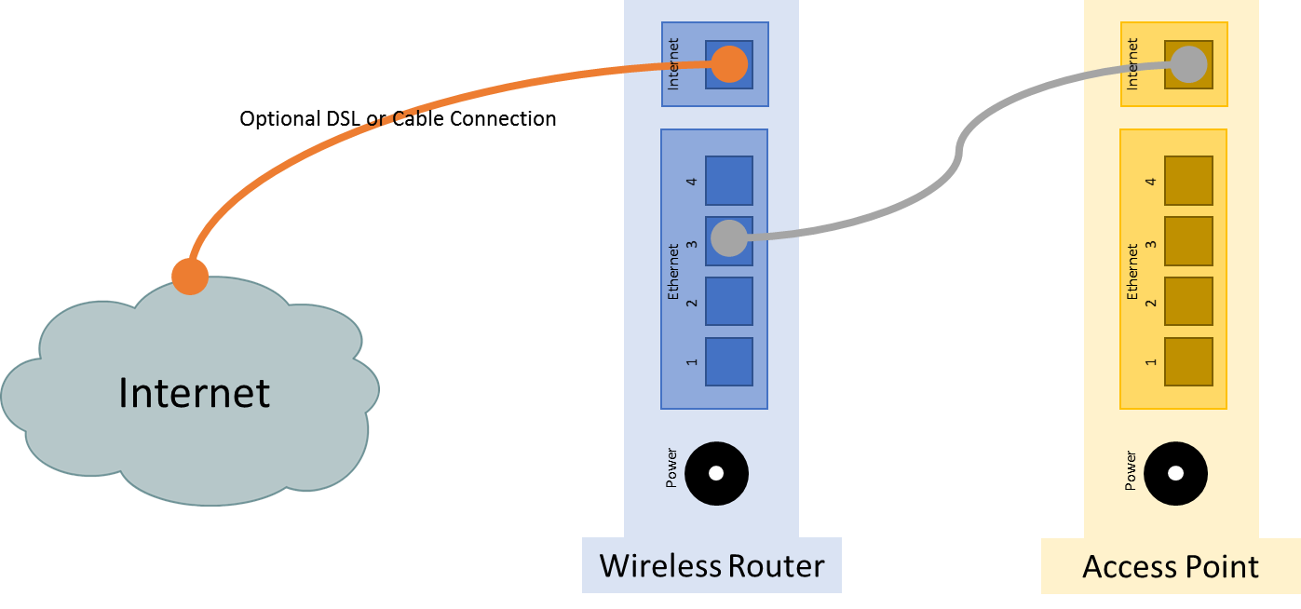

### Connect the access point to the wireless network.

* + - 1. Connect the wireless router via the Ethernet port. Navigate to the wireless router using a web browser using the IP address of the default gateway and log in as the administrator.
      2. To prevent interference, navigate to the wireless settings. Change the wireless channel from the default channel 1 to channel 6 or 11 on the wireless router. Save the new settings.
      3. Connect the Internet port of the access point to one of LAN ports on the existing wireless router.

### Configure access point wireless settings.

* + - 1. In the web page of the wireless router, navigate to the LAN settings to determine the IP address of the access point. The IP address of the access point can be listed in the address reservation table or DHCP client list.
      2. In another web browser, navigate to the IP address of the access point.
      3. In the access point settings, navigate to the wireless settings and configure the AP with the same wireless SSID and security options as the wireless router. For example, **ITE** as the SSID and WPA2 Personal AES with **Cisco456!** as the passphrase.
      4. Verify that the wireless router and AP are not using the same wireless channels.
      5. Attempt to connect a wireless client to the wireless network.

### Turn off wireless radio on the wireless router.

After you have successfully connected to the wireless network, you will attempt to disable the wireless router radio, and a wireless client will attempt to connect to the wireless network through the AP.

Depending on the wireless router model, you maybe able to switch off the wireless radio using the on/off switch.

* + - 1. Navigate to the wireless router using a web browser. If necessary, connect to the wireless router using a wired Ethernet connection.
      2. Navigate to the wireless settings, turn off the wireless router radio if available. The option to enable wireless radio may be in the advanced wireless settings.
      3. Save the settings.
      4. Attempt to connect a wireless client to the AP.

## Reset to the original configuration

Unless stated otherwise by the instructor, restore the router back to factory default if the option is available.

**Note**: Some wireless models have a reset button to reset the router to its default factory settings.

* + - 1. Locate the Maintenance or System settings.
      2. Click the selection to revert to factory default settings.
      3. Provide your administrative credentials if prompted.
      4. Wait for your router to finish reboot before shutting down the wireless router.

End of Document